Travel

The terrible truth behind the tranquility, revealed on D-Day Tour in Normandy, France
Sandy GuyThe West Australian
Sat, 29 July 2023 12:36PM
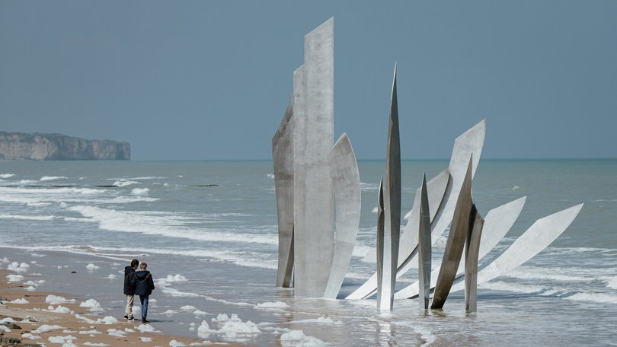A sculpture at Omaha Beach. Credit: Normandy Tourism/Supplied

On D-Day, Allied forces launched a massive combined naval, air and land assault on Nazi-occupied France.
Under the codename Operation Overlord, the Allied offensive was launched to create a new front and, ultimately, liberate Europe.
More than 2 million troops from more than 12 countries gathered in preparation for the invasion.
Allied forces consisted primarily of American, British and Canadian troops but also included Australian, Belgian, Czech, Dutch, French, Greek, New Zealand, Norwegian, Rhodesian and Polish naval, air and ground support.
Troops, tanks, all kinds of weapons, vehicles, food and every imaginable type of support material were gathered at British ports along the English Channel — from the Thames Estuary to Falmouth in the west — waiting for the right conditions to cross the English Channel to France.
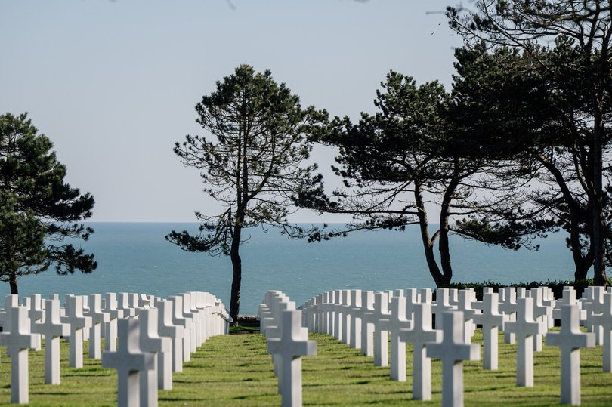
The American cemetery at Omaha Beach. Credit: Normandy Tourism/Supplied

It was the largest amphibious invasion in the history of warfare, when Allied forces used more than 5000 ships and landing craft to ferry more than 150,000 troops to five Normandy beaches, codenamed Utah, Omaha, Gold, Juno and Sword.
I learn some of the staggering statistics about D-Day at the Musee Memorial de la Bataille de Normandie, Bayeux’s fascinating World War II museum.
The following day I join a guided tour of some of the 80km stretch of landing beaches north of Bayeux, climbing aboard a mini-van with an English-speaking guide.
We head towards Sainte-Mere-Eglise, 57km west of Bayeux. Early on June 6 1944, Allied airborne forces parachuted into drop zones across northern France including Sainte-Mere-Eglise.
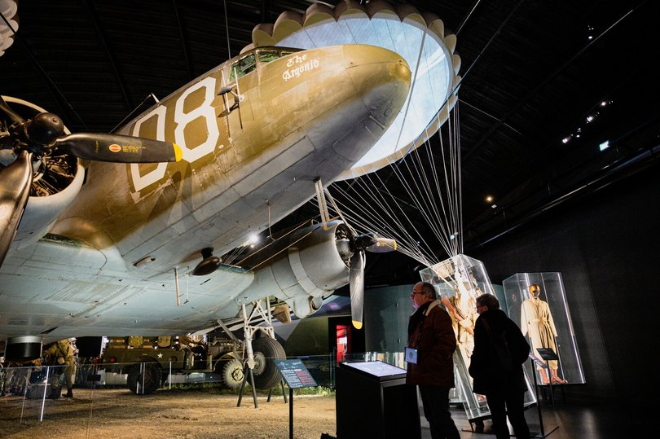
The Airborne Museum, Sainte-Mere-Eglise. Credit: Normandy Tourism/Supplied

The town features the Airborne Museum, one of many WWII museums, monuments, cemeteries and battle remains across the coast.
Travelling along narrow lanes in this still-rural area, our guide says the countryside remains much like it was on D-Day, when intense battles erupted among the dense hedgerows.
From here it’s 12km to Utah Beach on the Cotentin Peninsula, the westernmost of the landing beaches.
A serene sweep of sands today, this beach was chosen to establish a beachhead in the Cotentin region to capture the town of Cherbourg and its deepwater port.
By the end of D-Day, more than 23,000 American soldiers and 1700 vehicles had landed here.
The excellent Utah Beach Landing Museum tells the story of D-Day in a series of exhibits and displays.
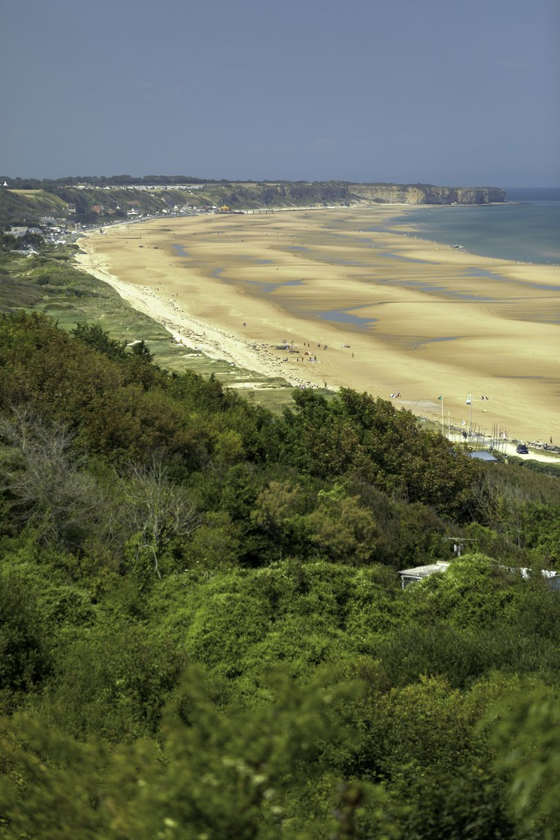
Omaha Beach. Credit: Normandy Tourism/Supplied

Omaha Beach, 48km east of Utah, was the eye of the D-Day storm, and the human cost of the invasion is inescapable at the vast American Cemetery, where rows of white crosses indicate the graves of 9387 soldiers as young as 18.
To further illustrate the futility of war, there are a sobering 27 military cemeteries in Normandy.
So many lives were lost at Omaha: D-Day was a day of terrible fighting, with Germans atop steep cliffs and bluffs along the beach pounding landing craft and troops trying to land with mortars and murderous machine-gunning.
By the end of the day, 34,000 troops had landed at Omaha in terrible conditions. There were 2400 casualties.
Strolling along the crescent-shaped beach, it’s a struggle to reconcile the lovely beach with waves lapping on the shore and seagulls squawking overhead with the horrible toll of invasion day, reflected at the Omaha Beach Memorial Museum, which showcases vehicles and archival photos.
At Arromanches-les-Baines, 24km east of Omaha, we see the remains of artificial harbours – Mulberries — which helped protect the landing of thousands of Allied troops and vehicles.
We learn about the temporary mobile harbours for unloading troops, vehicles and supplies at the seafront Musee du Debarquement, which recounts D-Day by way of models, machinery and movies.
D-Day was a crucial turning point in WWII. By the end of the day, the Allies had established a foothold along the coast and could begin their advance into France.
The following day, June 7, 1944, the lovely medieval town of Bayeux was the first city liberated from mainland France.
Five days after D-Day a total of 326,547 Allied troops had landed on the shores of Normandy. By the end of August 1944 there were more than 2m Allied troops in France.
Paris was liberated on August 25, 1944, after more than four years of nazi occupation.
PS The D in D-Day stands simply for “Day,” the designation given to the day of any significant military operation. The day before was known as D-1, the day after as D+1, and so on.
PPS This day in 1944 was the fifth day of Operation Cobra, in which American troops had infiltrated more than 13km inside the German lines. On the evening of July 29, the American forces reached the villages of Cerences, Cambry, Lengronne and Saint-Denis-le-Gast.

LEARNING MORE
The vast D-Day operation was incredibly complicated and difficult. I urge anyone considering visiting the Normandy landing beaches to read up on the subject before visiting. Suggestions include:
D-Day: The Battle for Normandy, Antony Beevor (2009);
Overlord, Max Hastings (1984);
The Struggle for Europe, Chester Wilmot (1952);
Eisenhower’s Lieutenants, Russell E Weigley (1981);
The Longest Day, Cornelius Ryan (1959).
fact file
Bayeux is about 2½ hours drive (260km) and two-hours, 15 minutes by train from Paris. For more information about travelling in France, visit au.franceguide.com.
Thirteen trains run between Paris and Bayeux every day. A single ticket starts from €16 ($26). Timetables at sncf-connect.com.
D-Day Tours
Omaha Beach/Utah Beach full-day tours departing Bayeux are from around €120 per person ($196). Several tour companies offer half, full-day, two-day and private D-Day tours. See information about local guided tours, private tours and independent guides at bayeux-bessin-tourisme.com. Tours also operate from Paris.
D-Day Festival
Each year around June 6 the D-Day Festival is organised by local tourist offices, and the anniversary includes parachute landings, a fireworks display, picnics, plays, and historical enactments. More at en.normandie-tourisme.fr.
The 80th anniversary of the D-Day Landings will he held on June 6, 2024.
For more information about Bayeux, go to bayeux-tourism.com, normandie-tourisme.fr

