Travel

Why Darjeeling suits travellers to a tea
Sandy GuyThe West Australian
Thu, 31 August 2023 3:34PM

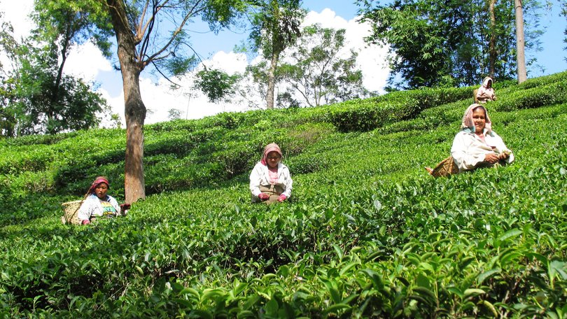Darjeeling. Glenburn Tea Estate pickers. Credit: Sandy Guy/Supplied

When the Darjeeling Himalayan Railway opened in 1881 the isolated town, on the mountainous north-western side of West Bengal, soon became one of one of the most popular hill stations in British India, a summer getaway for Europeans seeking to escape Calcutta’s unrelenting heat.
When the American author Mark Twain travelled up the mountains on the train in 1896 he said: “It was the most enjoyable day I have spent on Earth.
“The railway journey up the mountain is 40 miles, and it takes eight hours to make it. It is so wild and interesting and exciting and enchanting that it ought to take a week.”
Fascinating as the journey is, the steep slopes of the Himalayan foothills presented major challenges to the line’s builders, leading to some ingenious engineering work from the starting point at New Jalpaiguri Station on the Bengal plains, where the train departs on its 88km journey to Darjeeling.
The new line not only required almost 500 bridges to be built, engineers had to use loop techniques, whereby the train gains height by looping around a spiral similar to a spiral staircase, and Z-reverse technology, where the train moves backward and forward in order to overcome the difficulties of the hilly terrain.
There are six Z-reverse and three loops on the line to enable trains to gain altitude without losing traction.
The Darjeeling Himalayan Railway runs parallel with the narrow, profoundly potholed Hill Gap Road, which twists through dense jungle and tea gardens – there are 87 tea plantations in the region - and climbs unbelievably steep gradients towards Darjeeling, which lies 2128m above sea level.
The road — congested with trucks, vans, people and cows — and likewise the train — passes through villages where houses seem to dangle on the edge of precipitous mountains.
We thread through villages at a snail’s pace; train tracks pass right in front of shops, stalls, and houses.
Daily life spills almost on to the tracks; you see people going about their day’s work a few feet away. Kids smile and wave, and some dart on and off the train, it’s going so slowly.
As the train hauls its way up the mountains, I watch drivers navigate their cars on the Hill Gap Road with what seems a strict local code, tooting at corners and backing up when the road is too narrow for two cars to pass — which is frequently. This is one road visitors should never attempt to drive themselves.
Darjeeling commands incredible views of the Himalayas, which is broken up into fabulous formations of crests, spurs and valleys, overshadowed by the glistening white peaks of Mt Kangchenjunga, the world’s third highest mountain.
The town is a mix of colonial mansions and churches, Hindu and Buddhist temples, and narrow streets crowded with shops, bazaars, and ramshackle houses.
The Windamere Hotel, where photos of guests include Lord Mountbatten, the Aga Khan and Gone With the Wind star Vivien Leigh, who was born in Darjeeling in 1913, hasn’t changed much in a century.
It’s difficult to believe you’re in India at this relic of the British Raj — established from 1841 when it was built by the Raj Society as Ada Villa, the Windamere seems transported from an English village.
Wood-panelled guest lounges, where afternoon tea is the order of the day, have chintz-covered armchairs. I make my way across rose-festooned gardens with picket fences to my bungalow, which features more chintz-covered furniture and a small fireplace.
One charming bungalow, known as “The DHR Club,” is home to the Darjeeling Himalayan Railway Society, an international group with more than 800 members from 24 countries who support and promote the UNESCO World Heritage-listed railway, and members from around the world attend meetings here.
In the misty mornings I stroll to Observatory Hill, Darjeeling’s highest point and home to Mahakal Temple, a century-old temple that is a place of worship for both Hindus and Buddhists.
Near the temple, small monkeys dart at you from everywhere and it’s wise to hang on tight to your bags as you ascend the hill.
At the peak thousands of colourful prayer flags flap in the breeze, and the chants of Buddhist monks echo bewitchingly across the mountains. From here, on a clear day, snow-clad peaks stand like sentinels in the distance.
Darjeeling’s hub, Chowrasta Square, has several bookshops, antique stores and cafes serving momos, flavoursome Tibetan dumplings. From here, pilgrims mount ponies for the ride up to Mahakal Temple.
The town’s Himalayan Mountaineering Institute, co-founded by Darjeeling local Tenzing Norgay, who conquered Mt Everest with Sir Edmund Hillary in 1953, houses a collection of mountaineering memorabilia, and runs courses including trekking and rock-climbing.
Adjacent is the Padmaja Naidu Zoological Park, home to endangered animals including snow leopards, Tibetan wolves and red pandas.
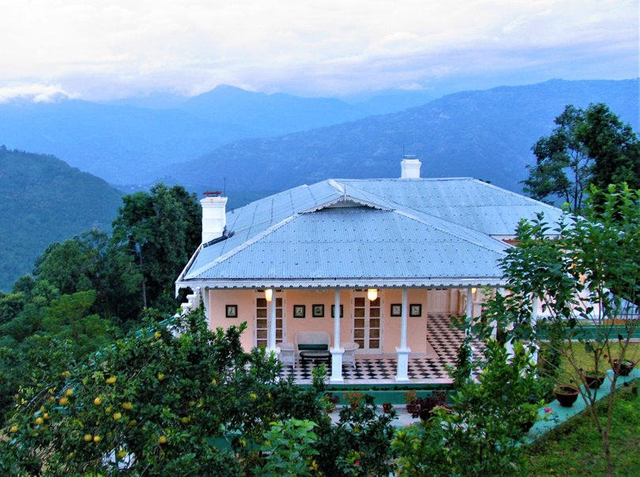Glenburn Tea Estate, Darjeeling. Credit: Sandy Guy/Supplied
Although only 12km from Darjeeling as the crow flies, it’s a 90-minute drive across winding, rutted roads to Glenburn Tea Estate, a haven of five-star luxury bordering the old royal kingdom of Sikkim.
The estate’s 150-year-old manager’s residence and two contemporary bungalows offer every creature comfort. Meals include first-rate Indian, European, Asian and Nepali cuisine.
Our room, the planter’s suite, has a splendid mahogany four-poster bed and a private veranda where we look out across the Simbong Valley towards the hills of Sikkim.
Allow at least three nights at this property, where you can tour the tea factory, trek to local villages, spend a night at Glenburn Lodge beside the Rung Dung River, where the waters run fast and green across enormous boulders, or simply relax with some Darjeeling tea and take in the spellbinding grandeur of the Himalayas.
In his later years, Mark Twain called India “the only foreign land I ever daydream about and deeply long to see again”. I know how he felt.
fact file
The Darjeeling Himalayan Railway is about AU$26.50 one-way from New Jalpaiguri station to Darjeeling. More information, including booking info at dhr.indianrailways.gov.in.
The Windamere Hotel has rooms from AU$219 per double per night, windamerehotel.com
Glenburn Tea Estate is from AU$790 per double per night and includes return chauffeur-driven transport from Bagdogra Airport or New Jalpaiguri station, all meals and tours, glenburnteaestate.com
For more information on visiting Darjeeling go to darjeeling-tourism.com and incredibleindia.org

