TravelEurope & UKFood & Drinks

Dinner by Heston at the Mandarin Oriental London
Sandy GuyThe West Australian
Sat, 16 November 2024 1:37PM
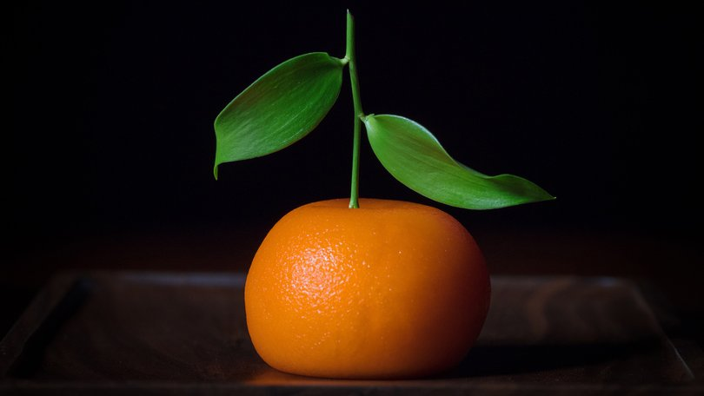Meat fruit. Credit: Dinner by Heston
Soon after Heston Blumenthal’s London restaurant, called Dinner, opened in 2011, rave reviews started flowing for the self-taught chef, famous for pushing culinary boundaries in dishes such as bacon and egg ice-cream, cauliflower with chocolate jelly, and sardine-on-toast sorbet at his Michelin-starred Fat Duck restaurant in Bray, west of London, and popular television programs.
“Astonishing”, “sprinkled with magic dust” and “bloody lovely” various critics declared of Dinner.
They weren’t wrong: my first meal at Dinner, a few months after it opened at the Mandarin Oriental Hyde Park, was a culinary masterpiece of historically-inspired British dishes served in the modern restaurant on the hotel’s ground floor.
That memorable meal has remained one of my all-time favourite culinary experiences. I have often wondered if it’s as good as I recall, and decided it was time to revisit.
The Mandarin Oriental, which sits grandly on the edge of Hyde Park, has been a citadel of luxury since the hotel opened in 1902.
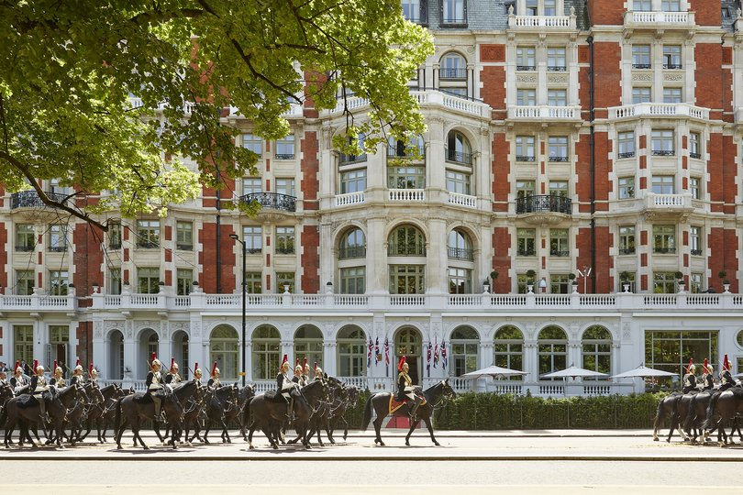Mandarin Oriental Hyde Park with Horseguards passing. Credit: Mandarin Oriental

In the elegant two Michelin-star restaurant, Dinner head chef Adam Tooby-Desmond and his team are on full display cooking in a glass-walled kitchen.
I start with meat fruit, a circa 1500 dish of chicken liver and foie gras parfait enrobed in mandarin jelly, artfully constructed to resemble a trompe l’oeil mandarin.
It feels criminal to cut into this incredible dish, which looks like a mandarin right down to its dimpled pores, but when I do, tasting the rich, silky parfait with its accompanying grilled sourdough bread, I want to applaud.
My companion is equally smitten with his starter of a medieval-inspired dish called Frumenty — octopus, spelt, smoked sea broth, pickled dulse — sea algae also known “sea lettuce flakes” — lovage, and slices of pickled Buddha’s hand fruit, a variety of citron.
Heston’s inspiration for Dinner’s menu — other starters include Hay Smoked Salmon with lemon salad dating from 1730, and Rice and Flesh, a risotto-like dish of calves’ tail, saffron and red wine that has its origins in the 14th century — come from old English cookbooks including The Forme Of Cury, a collection of recipes copied by the master cooks of King Richard II in around 1390.
Foodie time traveller Heston spent years researching and exploring Britain’s gastronomic past.
Dinner by Heston restaurant at Mandarin Oriental Hotel. Credit: Dinner by Heston
In 2004, looking for inspiration in his collection of medieval and Tudor cookbooks, Heston recalled a conversation he had two years earlier with Marc Meltonville, a food historian then based at the Tudor kitchens of Hampton Court Palace, at the Oxford Symposium of Food and Cookery, an annual conference on food history held at the university.
Sharing a passion for historic gastronomy, Heston and Marc began collaborating on historical dishes at Hampton Court’s historic kitchens and Heston’s Fat Duck restaurant in Bray.
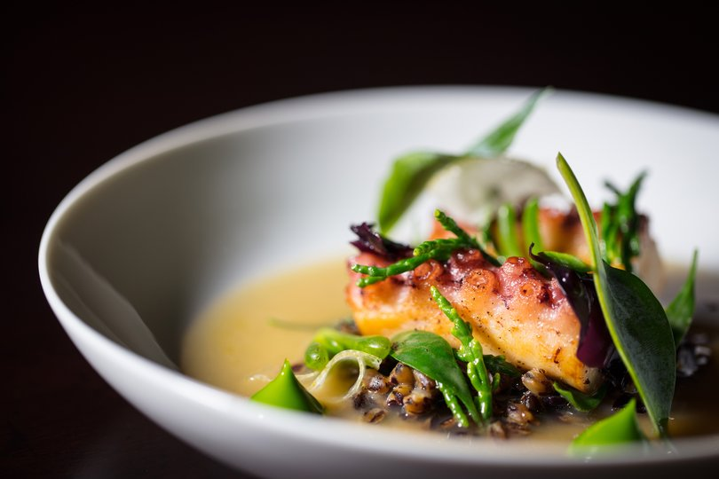Frumenty. Credit: Dinner by Heston

Their first dish was quaking pudding — “a sort of cross between a creme caramel and blancmange served piping hot,” Marc told me — which first appeared in The Accomplisht Cook in 1660.
“Because recipes from that time have no amounts, cooking times or temperatures, it took about 50 attempts to get the dish right.”
Recipes such as chocolate wine and buttered beer were similarly demanding, added Marc.
Perfecting the recipes on Dinner’s menu took months of experimentation: an original 15th century recipe from Hampton Court’s kitchens for “pommes” — spicy balls of minced veal rolled in a green batter made from a combination of parsley juice, flour and eggs, and cooked to look like apples — was the inspiration for Dinner’s exquisite meat fruit.
Our starters at Dinner are so good we wonder how the mains could possibly improve on them.
Choosing from such an incredible menu isn’t easy. There’s Chicken and Macrows — smoked cauliflower, king oyster and truffle — another 14th century recipe from The Forme Of Cury; circa 1780 Spiced Pigeon with ale and artichokes, and Roast Cod and Green Sauce from a 1440 recipe.
Perhaps we’re boring, but then again, we know of Heston’s scientific theories and methods about cooking perfect steaks, so eventually decide on Hereford Ribeye steak with mushroom ketchup, red wine jus and triple-cooked chips for two.
The tender, marbled steak — among the best I’ve eaten — is cooked to perfection, the accompanying rich mushroom ketchup and jus is delectable.
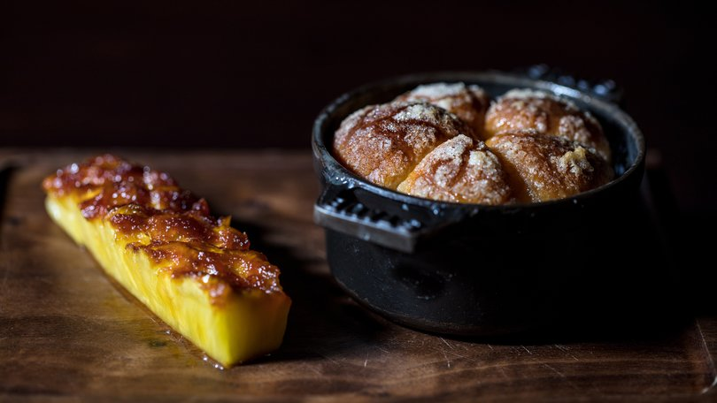Tipsy cake. Credit: Dinner by Heston

Dinner is no place to count calories, we decide, and order dessert — Tipsy Cake with spit roast pineapple, and Brown Bread Ice Cream.
The circa 1810 Tipsy Cake — hot, fluffy brioche-like buns accompanied by pineapple caramelised on a spit to a sweet intensity — is delicious. And the Brown Bread Ice Cream, from an 1830s recipe, a fusion of salted butter caramel and malted yeast syrup atop a crunchy, fudgy base, simply ambrosial.
Sated and happy, we retire upstairs to our spacious and elegant room, which features a big telly, fresh orchids, and a vast and deeply comfortable bed dressed with fine linens.
Tea is served by a butler — there’s one on every floor — with as much pomp and ceremony as if we’re among the royalty and celebrities who have stayed here. It couldn’t be a more splendid finale to an unforgettable dinner.
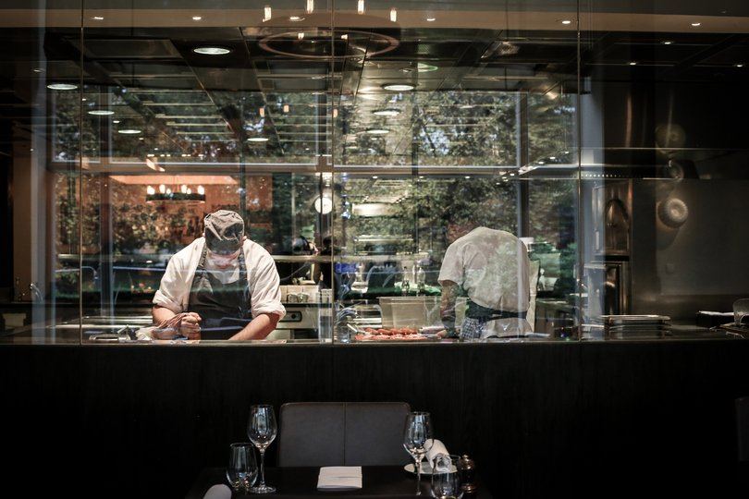Dinner by Heston restaurant at Mandarin Oriental Hotel. Main kitchen. Credit: Dinner by Heston

fact file
+ To learn more about the Oxford Symposium of Food History (July 11 to 13, 2025), visit oxfordsymposium.org.uk
+ The Mandarin Oriental Hotel is situated at 66 Knightsbridge, London. Rooms from around $2000 per double per night, mandarinoriental.com
+ A three-course a la carte meal like ours at Dinner costs in the neighbourhood of $450 (plus wine). A five-course Tasting Menu, held daily, is $312 per person, see these and more at dinnerbyheston.com.

