Travel

London for FREE
SANDY GUYThe West Australian
Sun, 21 May 2023 5:34PM
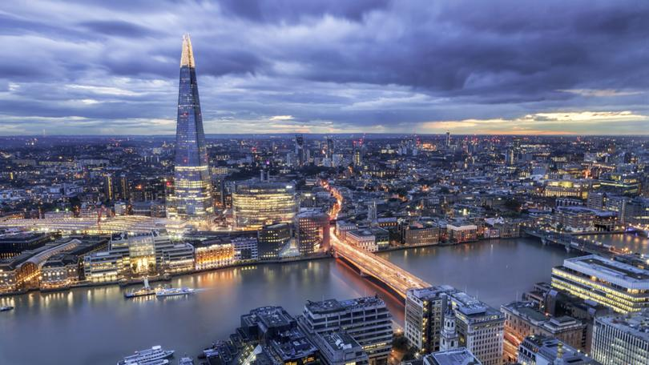City skyline at night and the Thames. Credit: VisitBritain/Supplied
In its 2000-year history, London has witnessed a procession of kings, queens, plagues, fires and wars, and each period of its chequered history has left an indelible mark on this ancient city.
There’s plenty for the modern-day tourist to see and do in London – aside from famous attractions such as Big Ben, Buckingham Palace and the Tower of London, there are 143 registered parks and gardens and more than 300 museums and galleries. Better still, more than 200 of the city’s attractions are free, including all of the attractions listed here.
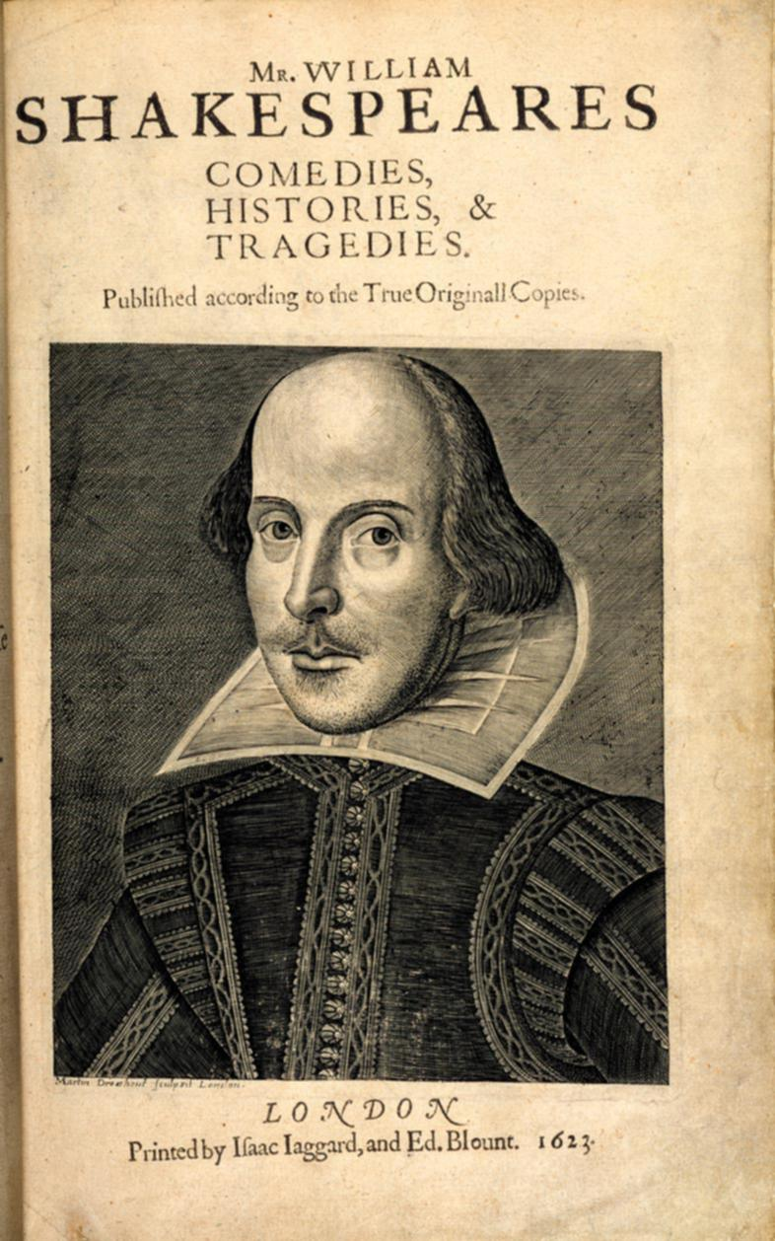British Library, Shakespeare first folio from 1623. Credit: British Library/Supplied
Treasures of the British Library A book-lovers dream, the John Ritblat Gallery at the British Library houses a magnificent collection of literature ranging from the Magna Carta and sacred religious texts to Leonardo Da Vinci’s notebook, Shakespeare’s first book, and original writings from the likes of the Brontes and Tolstoy. It is at 96 Euston Road, Camden, London. bl.uk
British Museum With more than six million objects from the Rosetta Stone to the Mildenhall Treasure — a hoard of 34 masterpieces of Roman silver from the 4th century — the British Museum is one of the great treasure houses of the world. Plan at least a day to view some of the incredible array of antiquities. It is in Great Russell Street, London. britishmuseum.org
Kenwood House Perched on the edge of Hampstead Heath, this stately historic home is home to all sorts of treasures including a Rembrandt self-portrait, works from Vermeer, Reynolds and Gainsborough, and portraits of Tudor and Stuart celebrities. Take a picnic and loll on the manicured lawns, and stroll leafy parklands in Hampstead Lane, Hampstead. www.english-heritage.org.uk
Museum of London The Museum of London at Docklands collects a huge variety of objects relating to London, its history and people, with exhibitions including Royal Connections, the Great Fire of London and Women’s History Collection. No 1 Warehouse, West India Quay, Docklands. museumoflondon.org.uk
Gunnersbury Park Once home to the Rothschild family, this 19th century mansion boasts Victorian kitchens, Roman and medieval pottery, Chinese ceramics and extensive parkland with a Gothic bathhouse and historic Orangery. Popes Lane, London. visitgunnersbury.org
Sir John Soane’s Museum This little-known beauty houses a cache of curios stockpiled by the architect John Soane, who died in 1837. The museum has been kept as it was at the time of Soane’s death, and displays his vast collection of antiquities, furniture, sculptures, architectural models and paintings, including artefacts from Etruscan, Roman and medieval periods. 13 Lincoln’s Inn Fields, London. soane.org
National Maritime Museum This museum is home to more than two million items relating to seafaring, navigation, astronomy and time measurement. Romney Road, London. rmg.co.uk
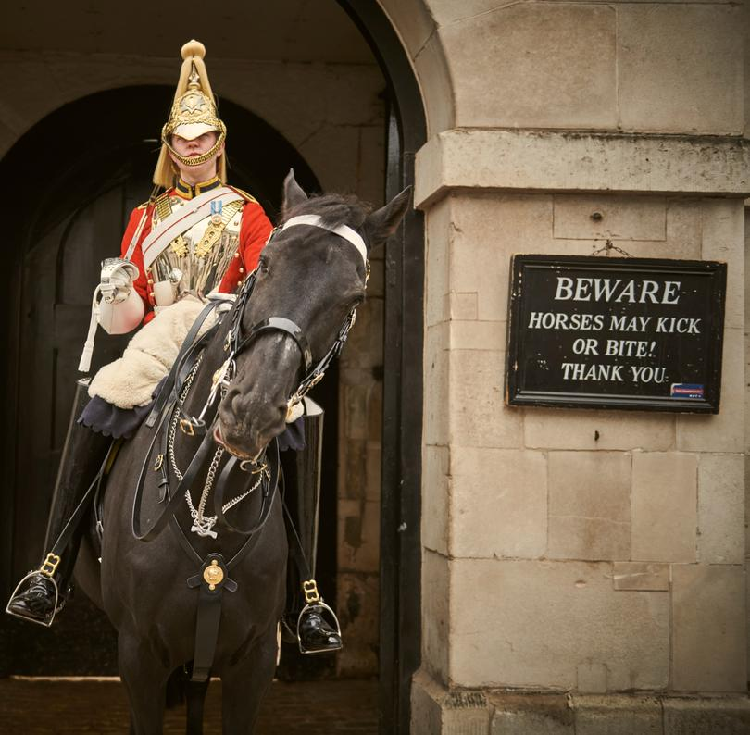Horseguard at Buckingham Palace. Credit: VisitBritain/Supplied
Changing of the Guard The bands play and the colourfully dressed soldiers cross the forecourt of Buckingham Palace in the much-loved pomp of the Changing of the Guard ceremony. Every Monday, Wednesday, Friday and Sunday from 11am (Windsor Castle every Tuesday, Thursday and Saturday). householddivision.org.uk
Victoria and Albert Museum Plan plenty of time to explore this remarkable museum, chock-a-block with artefacts covering a 3000-year period. Galleries brimming with riches from around the world include ceramics, sculpture, jewellery, textiles, furniture, fashion, photographs, and superlative artworks. Cromwell Road, London. vam.ac.uk
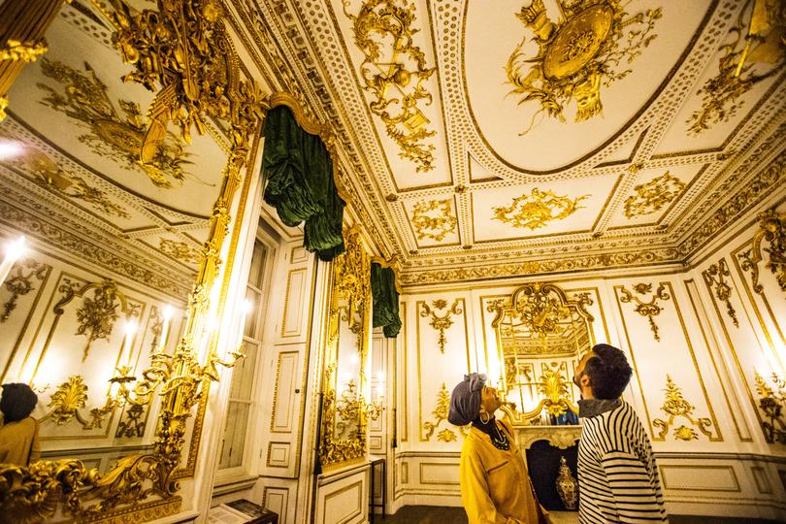Victoria & Albert Museum. Credit: VisitBritain/Supplied
The Wallace Collection This hidden gem features 25 galleries of paintings from the likes of Titan, Velazquez, and Hals famous Laughing Cavalier; furniture, Limoges enamels, porcelain, and a fine collection of arms and armory. Hertford House, Manchester Square, London. wallacecollection.org
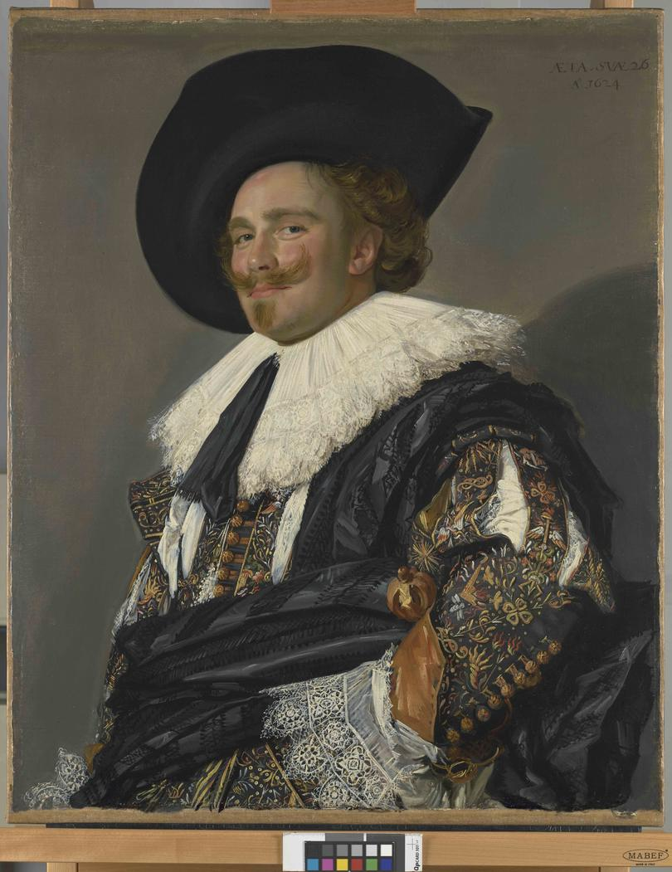Frans Hals - The Laughing Cavalier at Wallace Collection. Credit: Wallace Collection/Supplied
Imperial War Museum Battle buffs can explore exhibits ranging from tanks and aircraft to personal letters, films, ration books, moving recordings from World War I veterans, and all sorts of interesting exhibitions from the Battle of Britain to the Falklands War. Lambeth Road, London. iwm.org.uk
Science Museum See, touch and experience major scientific advances of the last 300 years at this incredible museum, the largest of its kind in the world, featuring 40 galleries and 2000 hands-on exhibits. Exhibition Road, London. sciencemuseum.org.uk
The National Gallery This remarkable gallery houses one of Europe’s greatest collections of paintings including works by Botticelli, da Vinci, Rembrandt, Cezanne and Van Gogh. Trafalgar Square, London. Open daily (quietest times are week-day mornings) with free tours too. nationalgallery.org.uk
National Portrait Gallery See faces from the past and present looking down from the walls of the gallery, home to the portraits of thousands of celebrated Brits through the centuries from Henry VII to William Shakespeare to Sir Paul McCartney. St Martin’s Place, London. Reopening on June 22, 2023, following major refurbishment. npg.org.uk
Horniman Museum While away hours amid anthropological and natural history treasures from Egyptian mummies and Inuit seal-skin clothing to stuffed walruses, as well as more than 9000 musical instruments at this great attraction. Pack a picnic to enjoy in the museum’s hectares of gardens. 100 London Road, South London. horniman.ac.uk
Petrie Museum of Egyptian Archaeology This intriguing museum boasts some 80,000 thousand exhibits of Egyptian and Sudanese archaeology dating back 5000 years. Illustrating life in the Nile Valley from prehistory through the time of the pharaohs, Roman and Coptic periods to the Islamic period, it makes for an absorbing visit. University College, Malet Place, London. ucl.ac.uk/culture/petrie-museum
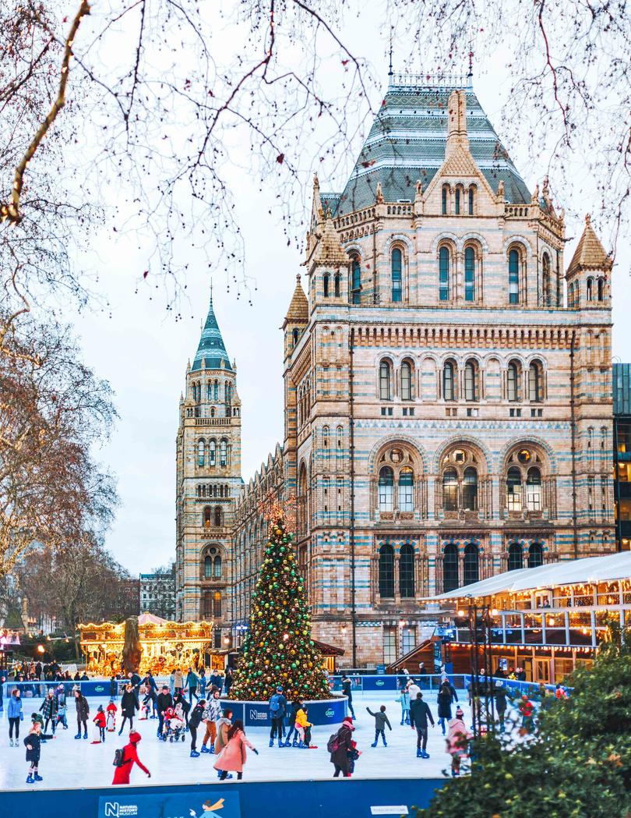Museum of Natural History. Credit: VisitBritain/Supplied
Museum of Natural History This amazing museum is home to more than 70 million specimens from dinosaurs to mammals to every bug, critter and creepy crawly imaginable, and includes excellent interactive displays and workshops. Cromwell Road, London. nhm.ac.uk
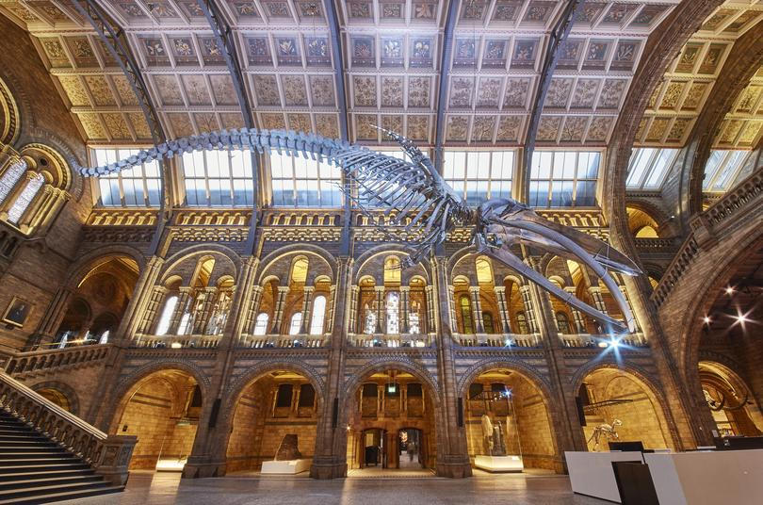Blue Whale in Hintze Hall at Natural History Museum. Credit: Natural History Museum/Supplied
Hunterian Museum Located within the Royal College of Surgeons, this collection holds more than 70,000 items across anatomical and pathological specimens, models, paintings and sculptures, covering the science of surgery from the 17th century. Exhibits include Winston Churchill’s dentures and a hair-raising collection of old surgical instruments. 35–43 Lincoln’s Inn Fields. rcseng.ac.uk/museums

fact file
Getting around
Bus is the best way to see the sights while getting around London. Grab a pocket-sized A to Z map (or download the app), which lists all the sights, and an Oyster Card, the cheapest way to pay for single journeys by bus, train and tube in London. You can buy a Visitor Oyster Card online before you leave home at tfl.gov.uk

