TravelEurope & UKHistorical Holidays

Diving deep into the history of Norfolk

Sandy GuyThe West Australian
Sat, 8 February 2025 1:12PM
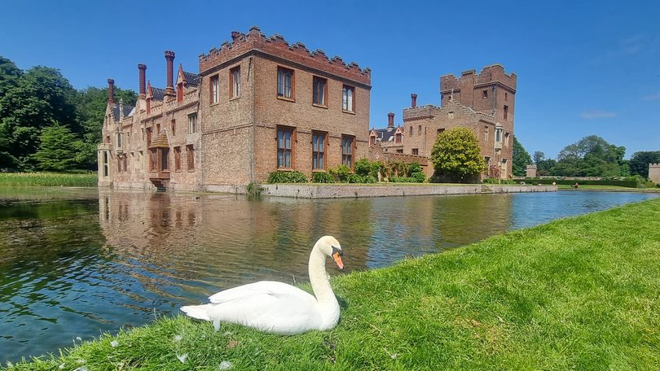Oxburgh Hall. Credit: Sandy Guy/The West Australian
Norfolk has the largest concentration of medieval churches in the world. Almost 1000 were built, and today an incredible 639 are still standing, their towers dominating the pretty much flat landscape of England’s southeast, known as East Anglia.
While Norfolk’s 145km coastline features some spectacular sweeping beaches, marshlands rich with birdlife, and seaside towns with long piers to promenade along, something visitors do during the warmer months, much of the countryside falls beneath the tourist radar.
Visiting some country areas is like a trip back in time; many towns and villages have grown little since the 1500s, their medieval infrastructure remaining relatively clear.
Norfolk has the largest concentration of medieval churches in the world. Almost 1000 were built, and today an incredible 639 are still standing, their towers dominating the pretty much flat landscape of England’s southeast, known as East Anglia.
While Norfolk’s 145km coastline features some spectacular sweeping beaches, marshlands rich with birdlife, and seaside towns with long piers to promenade along, something visitors do during the warmer months, much of the countryside falls beneath the tourist radar.
Visiting some country areas is like a trip back in time; many towns and villages have grown little since the 1500s, their medieval infrastructure remaining relatively clear.
Castle Acre near the ancient market town of Swaffham is a classic example, a rare survival of a Norman planned settlement.
Founded in the 1070s, the village includes the picturesque ruins of a castle and Castle Acre Priory, one of the best-preserved monastic sites in England.
This quaint village on the River Nar has a tearoom, a traditional pub, and an assortment of flint and brick cottages.
Across Norfolk are buildings faced with flint. It was mined at Breckland — called the Brecks — near Thetford, about 30km south of Swaffham.
The Brecks is home to Grime’s Graves, a 40ha site that looks like a green moonscape.
This strange, otherworldly place has more than 400 flint mines dug during the Neolithic period, around 5000 years ago, when flint was used to craft tools such as arrowheads and knives.
Much later, when metal replaced flint tools, flint nodules were in demand for other uses such as building.
At Grime’s Graves visitors can descend 9m below ground into Britain’s only open Neolithic flint mine and learn about the grim lives of prehistoric miners.
St George’s church in the village of Gooderstone, 16km north of Grime’s Graves is, like so many buildings in the region, constructed from flint and hewn stone.
Gooderstone is not a picture-postcard pretty village like Castle Acre, but it’s special to me.
Untold generations of my family were wed, baptised and buried at unpretentious St George’s, which dates from the 11th century; they sat on its 15th century wooden pews with carved backs, and probably dropped pennies into the 500-year-old wooden alms box.
Directly over the road from the church is The Swan, a low-ceilinged 17th century pub where plenty of ancestors probably repaired for a cosy pint.
Other than some pretty water gardens, that’s about all there is to Gooderstone, save for a school, and some historic properties scattered amid plenty of ho-hum 20th century houses.
But just 2km down the road is one of the UK National Trust’s most enchanting properties, the romantic moated manor Oxburgh Hall.
The walls of Oxburgh Hall rose in this quiet corner or Norfolk in 1482 built, unlike just about everything else in the neighbourhood, from red brick — fashionable and expensive at the time — rather than flint and stone.
Built by Sir Edmund Bedingfeld, the Hall is situated just outside the village of Oxborough (confusingly, it’s Oxburgh Hall but Oxborough village).
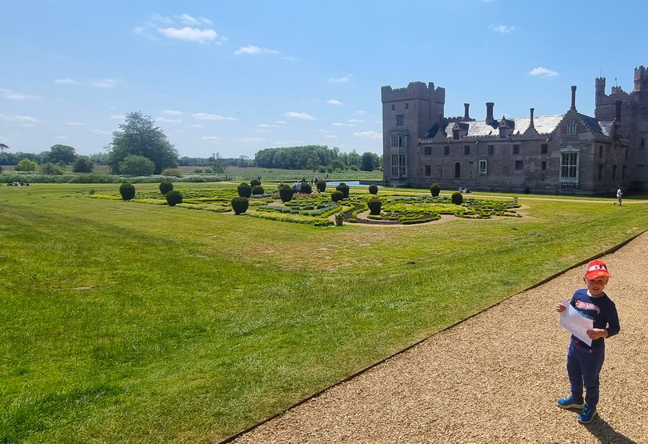Oxburgh Hall. Sandy Guy's grandson at Oxburgh Hall. Credit: Sandy Guy/The West Australian
The Bedingfield family were rising stars of the royal court in Tudor times, so much so that King Henry VII, founder of the Tudor dynasty, and his queen, Elizabeth of York, stayed here in 1487.
Oxburgh was built to impress, with a grand three-storey turreted gatehouse of fine brickwork.
On the first floor of the gatehouse is the spacious king’s room with a huge open fireplace and heavy oak furniture. Adjoining this chamber is a garderobe (toilet) and, in the corner, a brick-topped trapdoor concealing the entrance to a priest’s hole.
Henry VIII’s break with Catholic Rome during the 1530s, known as the English Reformation, meant momentous changes in Britain’s religious affairs.
Many aristocratic Catholic families like the Bedingfeld’s who had resident or visiting priests constructed hideouts like the one in their loo in case authorities raided their properties.
From the king’s chamber a narrow spiral staircase winds to the second floor and the queen’s equally grand chamber.
Although altered and extended over the centuries, Oxburgh Hall retains the feel of a medieval manor, rich with woodwork and leather-embossed walls. Most of the east, west and north wings feature original 15th century work.
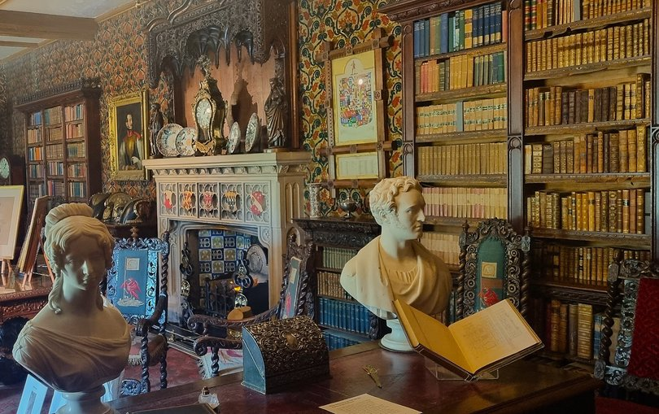Oxburgh Hall library. Credit: Sandy Guy/The West Australian
Highlights include the library, barely altered since the 1830s; the manor’s rich collection of portraits; Tudor manuscripts; historic wallpapers, and the amazing Oxburgh Hangings, beautifully embroidered panels created by Mary, Queen of Scots between 1569 and 1584 when she was incarcerated by Queen Elizabeth I.
The fortunes of the Bedingfeld family fluctuated over the centuries through religious persecution — they remained staunchly Catholic — Civil war and financial turmoil, leading to the loss of once vast acreages, and periods of near dereliction of the manor.
The Bedingfield’s were eventually forced to sell up: the Hall and its adjoining lands were auctioned off by Sir Edmund Paston-Bedingfeld, the ninth baronet, in 1950.
Lot number 1, the Hall and gardens, was purchased by a local merchant who planned to tear down the manor and sell the oak in the roof, the doors, and crush the red medieval bricks into rubble for paths and driveways.
Disaster was narrowly averted when Lady Sybil Paston-Bedingfeld, widow of the eighth baronet, her daughter and niece managed to scrape up the money to buy back the manor from the merchant, before offering it as a gift to the National Trust in 1952.
A proviso of the gift was that the Bedingfeld family continue to reside at Oxburgh Hall, continuing more than 500 years of residency in this tranquil corner of Norfolk.
Today the Bedingfeld’s occupy the eastern front of this ancient manor, while the remainder is open to the public, in an area that feels centuries away from the hustle and bustle of the 21st century.

fact file
+ Oxburgh Hall is open daily from 9.30am to 5pm (summer), 9.30am to 4pm (winter). Admission is £12 adults ($24), £6 ($12) children, nationaltrust.org.uk.
+ The Servant’s Hall Tearoom in the old kitchen serves light lunches and cream teas (scones, jam and cream), and there’s a second-hand bookshop tucked away in the walled kitchen garden.
+ The manicured grounds also feature a French-inspired parterre, a walled wilderness area, and shady My Lady’s Wood.
+ The National Trust website sets out several walks of different lengths and duration including the 5.6km Oxborough to Gooderstone Heritage Walk.
+ Grime’s Graves is open daily from 10am to 5pm. Admission £9 ($18) adults, more at english-heritage.org.uk.
+ For information on travelling in Norfolk, visit visitnorfolk.co.uk.
+ Interesting fact: East Anglia was one of the kingdoms of Anglo-Saxon England, consisting of the north people (Norfolk), the south people (Suffolk), and adjacent communities.

Stay
+ Oxburgh Chapel Lodge at Oxburgh Estate is a small 19th century lodge with its own garden available for holiday rentals. It’s cosy but charming and sleeps two. Minimum two-nights, £494 ($990) for two-nights, book at nationaltrust.org.uk.
+ The Bedingfeld Arms, just down the road from Oxburgh Hall at Oxborough, dates from 1783. This friendly tavern has comfortable rooms from £85 ($170) per double, and restaurant menus may include venison and redcurrant suet pudding, and Norfolk oak-smoked fish board, bedingfeldarms.co.uk.
+ The Ostrich at Castle Acre is a 16th century coaching inn set on the village’s ancient green. This venerable boozer has six rooms with ensuites from £120 ($240) per double per night, theostrichpub.co.uk.
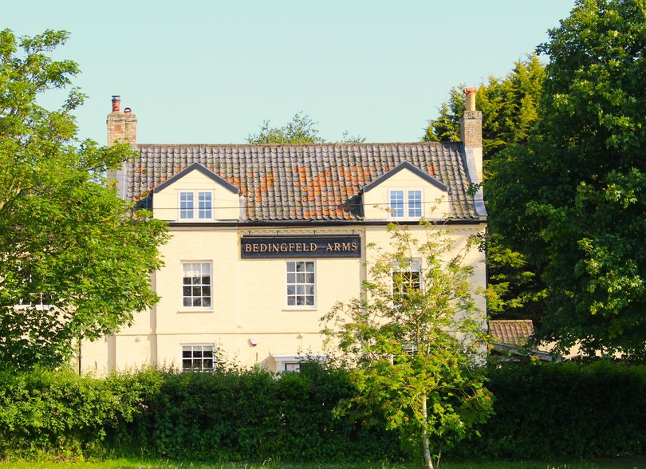Oxborough village. Bedingfeld Arms. Credit: Sandy Guy/The West Australian

Gooderstone. St George's, Gooderstone. Credit: Sandy Guy/The West Australian
